

Test Closure Report

Project Name: MockJeera

****Prepared**** by:

Pakricorn Techno Solutions PVT LTD.

Contents

1. Test Summary 3

1.1 Document Purpose 3

1.2 System/System Integration Test (QA/UA) 3

2. Test Items: 3

2.1.1 Summary of Test Case Execution 3

2.1.2 Variance to Plan and Associated Risk 4

2.1.3 Summary of Defects 4

2.1.4 Description of All Outstanding Defects 4

2.1.5 Exit Criteria Results (Was Exit Criteria Met or Not) 5

**Revision History**

|  |  |  |  |
| --- | --- | --- | --- |
| **Version Number** | **Revision Date** | **Summary of Changes** | **Modified by** |
| V.1 |  |  |  |
| V.2 |  |  |  |
| V.n |  |  |  |

**Contributors**

| **Name** | **Title** |
| --- | --- |
| QA Lead Name | QA Lead |
|  |  |

**Approvals**

|  |  |  |  |
| --- | --- | --- | --- |
| Signature: |  | Date: |  |
| Print Name: |  |  |  |
| Title: | Deputy PMO Director |  |  |
| Role: | Program PMO Director |  |  |

|  |  |  |  |
| --- | --- | --- | --- |
| Signature: |  | Date: |  |
| Print Name: | Uday Pukkala |  |  |
| Title: |  |  |  |
| Role: | Program Director |  |  |

|  |  |  |  |
| --- | --- | --- | --- |
| Signature: |  | Date: |  |
| Print Name: | Anudeep Yerrola |  |  |
| Title: |  |  |  |
| Role: | Test Manager |  |  |

|  |  |  |  |
| --- | --- | --- | --- |
| Signature: |  | Date: |  |
| Print Name: |  |  |  |
| Title: |  |  |  |
| Role: | PMO TCOE Auditor |  |  |

# Test Summary

## Document Purpose

The purpose of this document is to provide transparency of test results once the exit criteria has been met for one or more base test phases. This document may be used as a communication mechanism when a test milestone has been completed (QA, UAT) or as a Test Summary Closure Report at the conclusion of a Project.

# System/System Integration Test (QA/UA)

## Test Items:

Note: This section needs to be updated with the summary of the scope and list down the application/System/Database which are tested.

### Summary of Test Case Execution

|  |  |  |
| --- | --- | --- |
| **Item** | **Number** | |
| **Test cases planned/targeted for execution:** |  | |
| **Test Case State** | **Number** | **Percentage** |
| Passed |  |  |
| Failed |  |  |
| N/A |  |  |
|  |  |  |

Note: 1) Please update test run link from Adaptivity 2) Please add a Graph from final report

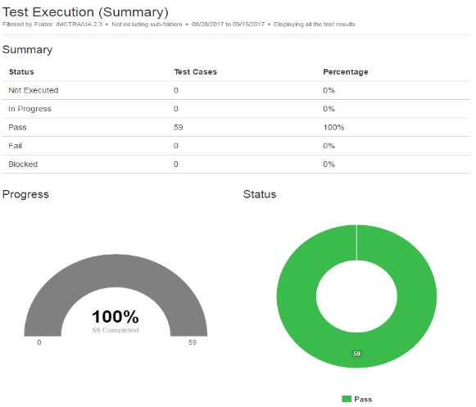

### Variance to Plan and Associated Risk/Assumptions

Note: This section needs to be updated if there are any variance from actual plan.

### Summary of Defects

|  |  |  |  |  |  |  |  |
| --- | --- | --- | --- | --- | --- | --- | --- |
| **All Defects, by Severity, by Status** | | | | | | | |
| **Defect Severity** | **Open** | **In Progress** | **Resolved** | **Reopened** | **Closed** | **Deferred** | **Grand Total** |
| 1-Critical |  |  |  |  |  |  |  |
| 2-High |  |  |  |  |  |  |  |
| 3-Medium |  |  |  |  |  |  |  |
| 4-Low |  |  |  |  |  |  |  |
| Grand Total |  |  |  |  |  |  |  |

Note: Please add a Graph from final report

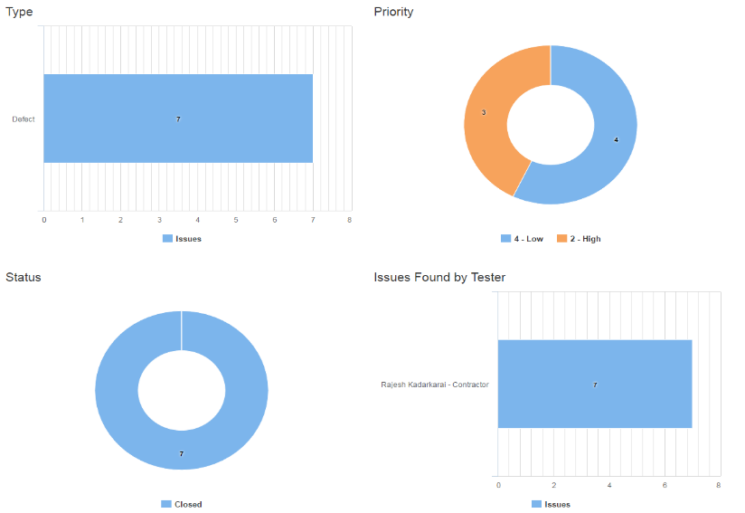

### Description of All Outstanding Defects

|  |  |  |  |
| --- | --- | --- | --- |
| **QA/UA**  **Defect ID** | **Priority** | **Brief Description of Defect** | **Resolution Plan** |
|  |  |  |  |
|  |  |  |  |
|  |  |  |  |
|  |  |  |  |
|  |  |  |  |

### Exit Criteria Results (Was Exit Criteria Met or Not)

Copy this section from the Master test plan

### Traceability Report

### Performance Report

### Final Recommendation